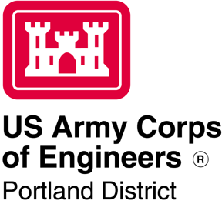

Willamette Fish Operations Plan

Willamette Valley Project

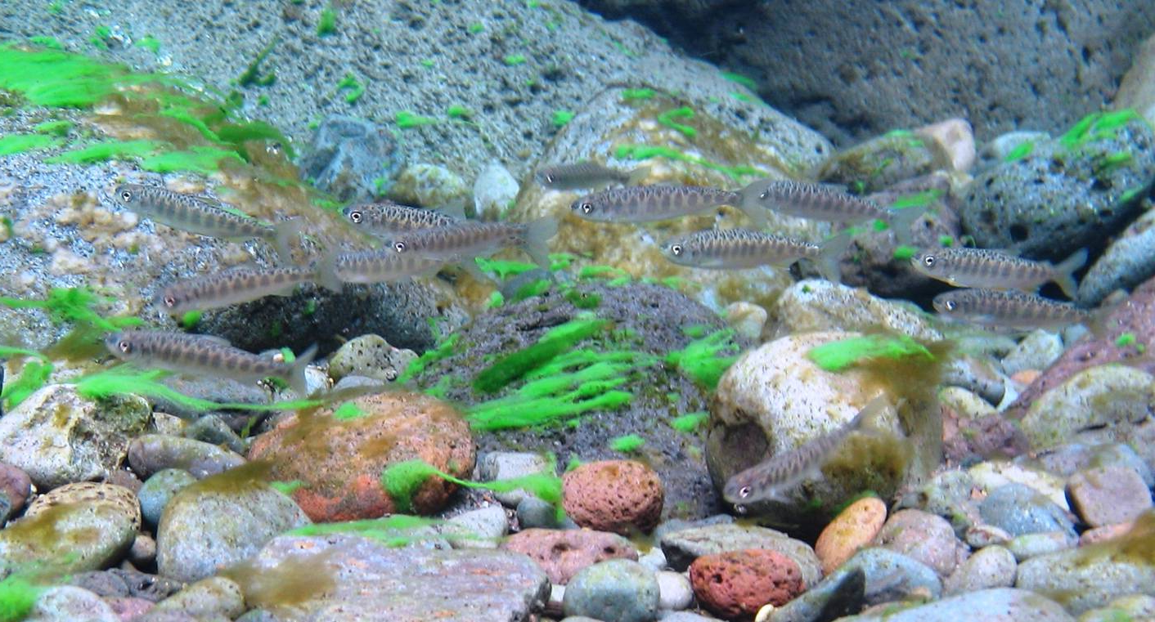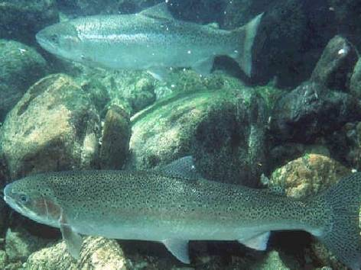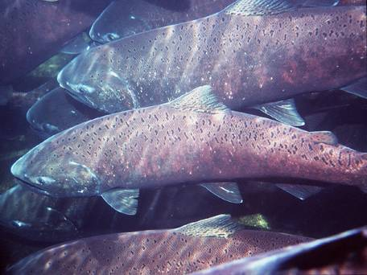

**Table of Contents**

Chapter 1 – Overview (OVE)

Chapter 2 – North Santiam (NS)

Chapter 3 – South Santiam (SS)

Chapter 4 – McKenzie (MCK)

Chapter 5 – Middle Fork Willamette (MFW)

**APPENDICES**

Appendix A – Fish Operations

Appendix B – Project Features (Dams)

Appendix C – Minto Fish Facility O&M Manual

Appendix D – Foster Fish Facility O&M Manual

Appendix E – Cougar Fish Facility O&M Manual

Appendix F – Rule Curves

Appendix G – Outplant Forms

Appendix H – Gate Construction Schedule

Appendix I – Notification Protocol: Flow Deviations and Power Generation Requests

Appendix J – Acronyms

Appendix K – Maintenance Periods for Willamette Valley Projects

1. Willamette FISH Operations PLAN (WFOP) OVERVIEW
   1. Background
      1. The *Willamette Fish Operations Plan* (WFOP) is developed annually by the U.S. Army Corps of Engineers (Corps) in coordination with the Bonneville Power Administration (BPA) and regional Federal, State and Tribal fish agencies and other partners through the *Willamette Fish Passage Operations & Maintenance* (WFPOM) coordination team. The WFOP describes year-round operations and maintenance (O&M) activities at Corps projects in the Willamette Basin (**Figure OVE-1**) as coordinated through WFPOM to protect and enhance anadromous and resident fish species listed as endangered or threatened under the *Endangered Species Act* (ESA), as well as non-listed species of concern. The WFOP guides USACE actions related to fish protection and passage at the 13 Willamette projects. Other Corps documents and agreements related to fish passage at these projects are consistent with the WFOP.
      2. Pursuant to ESA Section 7, NOAA Fisheries and U.S. Fish and Wildlife Services consulted on the effects of Willamette project operations on ESA-listed fish species and issued a Biological Opinion (BiOp) on July 11, 2008, that included a suite of recommended actions and strategies in the *Reasonable & Prudent Alternative* (RPA). The BiOps, decision documents and other related information are available online at: <http://www.salmonrecovery.gov/BiologicalOpinions/WillametteBiOp.aspx>
      3. The WFOP is developed in accordance with the NOAA Willamette BiOp RPA Action 4.3 for the operation and maintenance of Willamette Valley dams and fish passage facilities to minimize impacts to fish. The WFOP is revised as necessary to incorporate changes to project O&M as a result of new facilities or changes in operational procedures. Revisions will incorporate changes adopted through coordination with NOAA Fisheries and USFWS as part of the ESA Section 7 consultation, Recovery Plan, or Incidental Take permit processes, and through consideration of other regional input and plans. If any revisions to the WFOP are necessary, they will be made in accordance with the coordination process for revisions. Comments on the WFOP are welcome and may be sent to WFPOM and/or the Corps’ Portland District Operations Division Fisheries Section, in Portland, Oregon. Draft and final WFOPs from 2015 through present, including all Change Forms, are available online at the *Willamette Fish Operations Plan Website*: <http://pweb.crohms.org/tmt/documents/FPOM/2010/Willamette_Coordination/WFOP/>

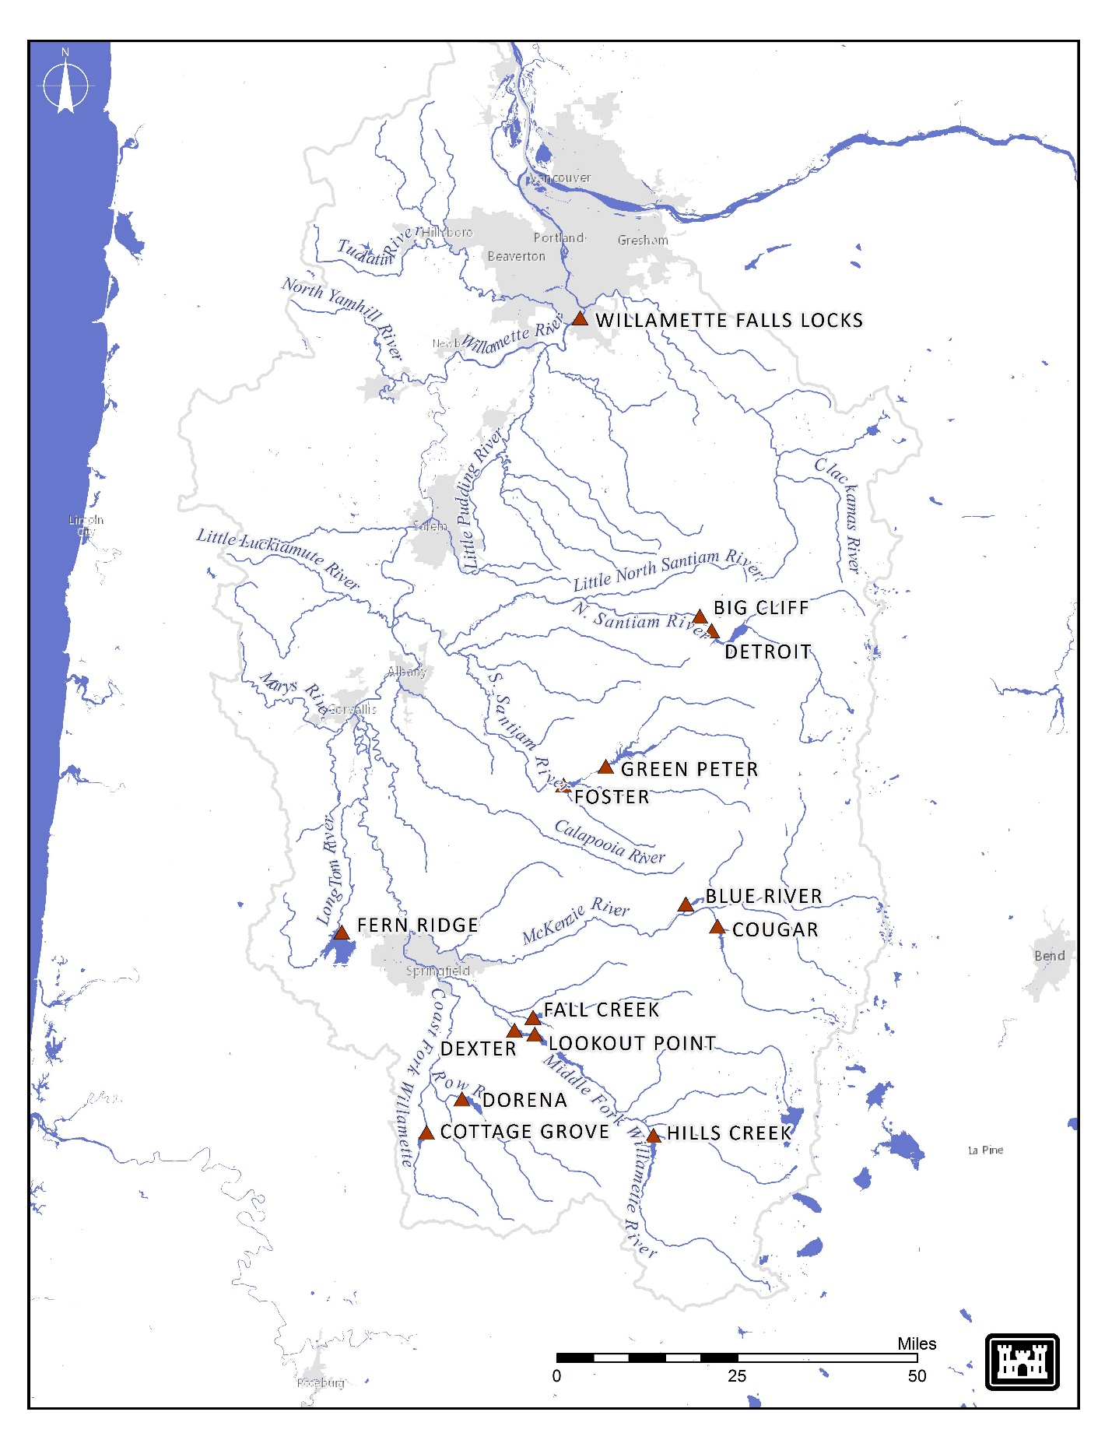

Figure OVE-1. Willamette River Basin and NWP USACE dams.

* + 1. **ESA Listed Fish**

Upper Willamette River (UWR) spring Chinook (*Oncorhynchus tshawytscha*), UWR winter steelhead (*O. mykiss*), and bull trout (*Salvelinus confluentus*) are ESA-listed fish species found in the Willamette subbasins affected by operation of the WVP. Oregon chub were delisted in 2015. The distribution of each species by subbasin is provided in **Table OVE-1**.

Table OVE-1. ESA-listed Fish Presence by Willamette Subbasin

|  |  |  |  |  |  |
| --- | --- | --- | --- | --- | --- |
| **Subbasin** | **WVP Facilities** | **Fish Species** | | | |
| **Spring**  **Chinook** | **Winter**  **Steelhead** | **Bull**  **Trout** | **Oregon**  **Chubc** |
| North Santiam | Detroit/Big Cliff | **Present** | **Present** | Absent | **Present** |
| South Santiam | Green Peter (Middle Santiam)/  Foster (South Santiam) | **Present** | **Present** | Absent | **Present** |
| McKenzie | Cougar (South Fork McKenzie)/  Blue River | **Present** | Absentb | **Present** | **Present** |
| Middle Fork Willamette | Hills Creek/Lookout Point/Dexter | **Present** | Absentb | **Present** | **Present** |
| Fall Creek | Fall Creek | **Present** | Absentb | Absent | **Present** |
| Long Tom | Fern Ridge | Absenta | Absent | Absent | Absent |
| Coast Fork Willamette | Dorena | Absenta | Absent | Absent | **Present** |
| Row River | Cottage Grove | Absent | Absent | Absent | Absent |

a Juvenile spring Chinook salmon have been documented using lower accessible reaches for winter off-channel use.

b Winter steelhead in the McKenzie and Middle Fork Willamette rivers and in Fall Creek are not designated as part of the distinct

population segment but may be present in small numbers. Source: NMFS 2008

c Oregon Chub were delisted in 2015.

* 1. Emergency Deviations from Fish Passage Plan (WFOP) Criteria
     1. The phrase "*when practicable*" is used in the WFOP to describe Project actions for fish that may vary on a case-by-case basis and thus require the exercise of professional judgment by Project staff. These situations may be due to real-time biological and/or other environmental conditions, availability of Project staff and/or equipment, or integrity of fish facility or other dam structures. In these cases, the Project biologist and other Project personnel will consider all relevant factors to determine the best way to proceed and implement appropriate action. These actions will be coordinated with fish agencies and tribes via the MOC/MFR process when they deviate from the WFOP.
     2. River operational emergencies may occur that require projects to temporarily deviate from the WFOP. To the extent practicable, these operations will be coordinated with fish agencies and tribes via the MOC/MFR process, and conducted in a manner to avoid or minimize fish impacts. Normally, coordination occurs prior to an action; however, if an emergency situation requires immediate attention, coordination will be completed as soon as practicable afterwards.
  2. Flow Management and Water Quality Team (FMWQT)
     1. In-season decisions on dam operations will be made in coordination with the regional forum *Flow Management and Water Quality Team* (FMWQT). Special operations identified in the WFOP will be coordinated through FMWQT. FMWQT meets monthly, or as often as necessary. When a flow or water quality specific operation is required, a Memorandum of Coordination (MOC) is distributed to the region for documentation and coordination through the WFPOM forum. Decision tools will be provided to assist for flow requests and/or alternatives when feasible. Detailed information regarding the MOC process can be found in Section 2.4.2.1. below.
     2. Water Conservation Planning Process
        1. The USACE prepares an annual plan for the conservation release season (April/May-October). This plan is drafted in the spring, in coordination with the FMWQT, and finalized in May and an update will be given and coordinated through WFPOM. The Conservation Plan describes how the authorized project purposes will be accomplished during the conservation season based on the water supply forecast.
        2. The plan calls for setting operational flow targets at Salem beginning on April 1, based on a storage forecast (e.g. adequate, insufficient) for mid-May (May 10-20).
        3. BiOp RPA 3.4 excerpt during deficit years:

“(a) In “deficit” water years (as defined in Appendix D), the USACE will inform Reclamation that either (1) a specified partial supply or (2) no supply is available for the upcoming irrigation season in specific tributaries and will include this determination in the annual operating plan. The April 1 determination will remain in effect until October 31. The USACE may revise its “deficit” water year determination after April 1 if forecasts change significantly toward a wet year, and may make additional stored water available to meet irrigation contracts.

(b) Reclamation will notify affected contractees that water deliveries will be ceased or curtailed under these circumstances. Reclamation may apply the curtailment or cessation of water deliveries to specific tributaries where it is needed, but not in others, depending on water availability and storage capacity in each basin’s reservoirs. Reclamation will also inform the OWRD of such actions.

(c) If the USACE determines initially that a partial supply is available for contractees, but later forecasts indicate even less water is available, in order to protect fish habitat the USACE will release additional flow from the applicable dams to offset the amounts diverted by contractees, based on the partial use that had been permitted on April 1. This additional flow will not be released if, based on coordination through WATER, it is determined these additional flows would impact ability to meet Table 9.2-1 (mainstem) and 9.2-2 (tributary) minimum flows during other seasons.”

* + 1. Streamflow. WVP dams were designed and constructed to modify the streamflow characteristics of their respective tributaries and the mainstem Willamette River. The storage facilities are drafted each fall to provide storage space for flood damage reduction and are refilled each spring to provide water for conservation season uses. Note that currently there are no Interim Risk Reduction Measures in effect. In general, WVP operations have resulted in higher flows in the summer and reduced peak flows in the winter than historical flows. These hydrologic effects, seasonally, modify fish habitat characteristics in the downstream stream reaches.
    2. The NMFS and FWS BiOps call on the Corps to release flows at WVP dams to achieve streamflow minimums in the tributaries and mainstem Willamette throughout the year and to stay below maximum flows during key spawning periods in the tributaries (Tables OVE-2 & OVE-3). Additionally, the BiOps establish ramping rates that the Corps strives to maintain, except during emergencies and flood control operations. These flow measures are described in the NMFS’ RPA measures 2.2 to 2.6. Mainstem flow targets for adequate and abundant water years are listed in table OVE-2.

*Table OVE-2. Mainstem Willamette Flow Objectives for “Adequate” & “Abundant” Years.*

|  |  |  |  |
| --- | --- | --- | --- |
| **TIME PERIOD** | **7-DAY MOVING AVERAGE 2 MINIMUM FLOW AT SALEM (CFS)**  **USGS 141910004** | **INSTANTANEOUS MINIMUM**  **FLOW AT SALEM (CFS) USGS 14191000** | **MINIMUM FLOW AT ALBANY (CFS) 3**  **USGS 141740005** |
| April 1 – 30 | 17,800 | 14,300 | --- |
| May 1 – 31 | 15,000 | 12,000 | --- |
| June 1 – 15 | 13,000 | 10,500 | 4,500 3 |
| June 16 - 30 | 8,700 | 7,000 | 4,500 3 |
| July 1 – 31 | --- | 6,000 3 | 4,500 3 |
| August 1 - 15 | --- | 6,000 3 | 5,000 3 |
| August 16 - 31 | --- | 6,500 3 | 5,000 3 |
| September 1 - 30 | --- | 7,000 3 | 5,000 3 |
| October 1 - 31 | --- | 7,000 | 5,000 |

1 Appendix D defines “Adequate” and “Abundant” water years, and also describes how flow objectives can be decreased in “Deficit” water years.

2 An average of the mean daily flows in cubic feet per second (cfs) observed over the prior 7-day period.

3 Congressionally authorized minimum flows (House Document 531). September flows were extended into October.

4 USGS gage 14191000 Willamette River at Salem, OR

5 USGS gage 14174000 Willamette River at Albany, OR

*Table OVE-3.* Minimum & Maximum Tributary Flow Objectives below Willamette Dams*.*

|  |  |  |  |  |  |  |
| --- | --- | --- | --- | --- | --- | --- |
| **DAM** | **PERIOD** | **PRIMARY USE** | **MINIMUM FLOW (CFS) 1** | **PERCENT OF TIME FLOW IS EQUALED OR EXCEEDED4** | **MAXIMUM FLOW (CFS) 2** | **PERCENT OF TIME FLOW IS EQUALED OR EXCEEDED4** |
| Hills Creek | Sep 1 - Jan 31 | Migration & rearing | 400 | 99.9 |  |  |
| Feb 1 - Aug 31 | Rearing | 400 | 99.9 |  |  |
| Fall Creek | Sep 1 - Oct 15 | Chinook spawning | 200 | 95 | 400 through Sep 30, when possible | 25 |
| Oct 16 - Jan 31 | Chinook incubation | 50 3 | 99.9 |  |  |
| Feb 1 - Mar 31 | Rearing | 50 | 99.9 |  |  |
| Apr 1 - May 31 | Rearing | 80 | 99.9 |  |  |
| Jun 1 - Jun 30 | Rearing/adult migration | 80 | 99.9 |  |  |
| Jul 1 - Aug 31 | Rearing | 80 | 95 |  |  |
| Dexter | Sep 1 - Oct 15 | Chinook spawning | 1200 | 99.9 | 3,500 through Sep  30, when possible | 10 |

1 When a reservoir is at or below minimum conservation pool elevation, the minimum outflow will equal inflow or the congressionally authorized minimum flows, whichever is higher.

2 Maximum flows are intended to minimize the potential for spawning to occur in stream areas that might subsequently be dewatered at the specified minimum flow during incubation.

3 The USACE will attempt to avoid prolonged releases in excess of the recommended maximum spawning season discharge to avoid spawning in areas that would require high incubation flows that would be difficult to achieve and maintain throughout the incubation period. When maximum flow objectives are exceeded for a period of 72 hours or longer, the WATER Flow Management Committee will review available

monitoring information (e.g., regarding redd deposition in relation to flow rates), projected runoff, and reservoir storage, and will formulate a recommendation for an appropriate and sustainable incubation flow rate prior to the initiation of the subsequent incubation period.

4 Flow duration estimates are based on HEC-ResSim model output data for the Biop operation. Period of Record of model data is Water Years 1936-2004.

* + 1. Water Temperature. The typical operation of the WVP dams with hydropower is to route water through the powerhouse of each dam, generating hydropower for regional energy demand. During the summer months, when reservoirs are at full pool, the water released through the turbine outlets is deep (hypolimnetic) water, which produces downstream water temperatures cooler than inflow temperatures (Figure OVE-2). During fall as the reservoirs are drawn down, the thermocline is pulled deeper and water released through the turbine outlets increases downstream water temperatures, which are much warmer than inflow temperatures (Figure OVE-3). Water temperature management operations occur at Cougar, Detroit, and Fall Creek Dams. Currently, a water temperature control tower is utilized for this at Cougar Dam with one planned for future use at Detroit Dam. Temperature management is performed at Detroit and Fall Creek Dams using existing outlets.

Figure OVE-2. Influence on Downstream Water Temperatures with no Temperature Control During Conservation Season.

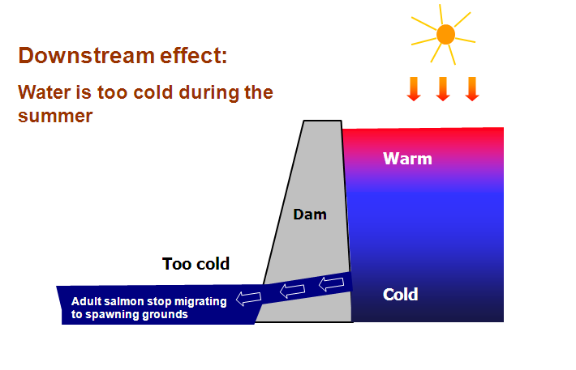

Figure OVE-3. Influence on Downstream Water Temperatures with no Temperature Control During Reservoir Drawdown for Flood Damage Reduction

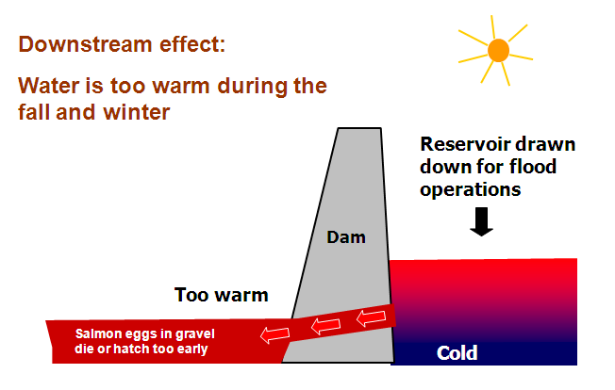

* 1. Invasive Species. The USACE has an established policy that requires measures be included in O&M that either prevent or reduce the establishment of invasive and non-native species. Non-native aquatic mussels, specifically zebra mussels, can have a significant impact on native species, as well as increase facility O&M costs. These organisms have become a serious problem elsewhere in the country and may become introduced into the Willamette Basin. Inspections will be made when dewatering all WVP fish facilities. Due to transfers of water and equipment both from within and outside the Willamette Basin, extreme diligence should be taken during transfers as the water or equipment may harbor invasive species. Immediate reporting of suspect or confirmed zebra mussels or other invasive aquatic species will be made to the USACE. If additional aquatic invasive species are identified and require monitoring, the WFOP will be revised to reflect these new species.
  2. Total Dissolved Gas (TDG) Monitoring
     1. The Federal *Clean Water Act* establishes total dissolved gas (TDG) aquatic life standard of 110% that has been adopted by the states of Washington, Oregon, Idaho and Montana. Oregon Administrative Rules 340-041-0031 states that waters will be free from dissolved gases, such as carbon dioxide, hydrogen sulfide, or other gases, in sufficient quantities to cause objectionable odors or to be deleterious to fish or other aquatic life, navigation, recreation, or other reasonable uses made of such water. Except when stream flow exceeds the 10-year, 7-day average flood, the concentration of TDG relative to atmospheric pressure at the point of sample collection may not exceed 110% of saturation. However, in hatchery receiving waters and other waters of less than 2 feet in depth, the concentration of TDG relative to atmospheric pressure at the point of sample collection may not exceed 105% of saturation.
     2. Each year, a Willamette Basin Annual Water Quality Report is drafted to address Reasonable and Prudent Alternative (RPA) 5.1.4 of the NMFS 2008 Biological Opinion (BiOp). This report documents water quality monitoring, data collection and improvement actions implemented throughout the Willamette Basin for that year.
     3. Real time high TDG alerts are available to interested individuals using the alert system provided by USGS for gages funded by the USACE and will require the individual to register for the service available at: <http://maps.waterdata.usgs.gov/mapper/wateralert/>.
     4. The Corps will report anticipated high flows (due to storms or operations) that are likely to result in elevated TDG levels below project facilities through the MOC process. All deviations/TDG exceedances that are not anticipated will be reviewed through the MFR process. In addition to the USGS alert system, the USACE will notify downstream facilities potentially impacted via telephone when high TDG levels are anticipated or occurring.
  3. Mitigation Hatcheries
     1. Mitigation Hatcheries. Since completion of the dams, both anadromous salmonids and resident trout have been produced and released into the Willamette Basin. These programs, intended to mitigate for the loss of winter steelhead, spring Chinook, and trout (rainbow and cutthroat), may have further impacted the wild populations of these species through direct and indirect interactions. Current hatchery production provides for sport and commercial harvest, tribal allocations, and brood stock production, as well as a stock source for reintroduction above WVP dams. As natural production increases as a result of actions implemented under the 2008 BiOp, consideration of reduced hatchery production may be warranted. ***Hatchery operations are directed by Hatchery Genetic and Management Plans currently in review and will be incorporated as appendices once approved.***
  4. Adult Outplanting Plan
     1. Criteria for adult fish facilities are contained in the project-specific **WFOP** **Chapters 2–5**. Additional criteria may be developed as part of the ESA Section 10 permit process and/or in coordination with the WFPOM.

1. Fish Passage Facilities – Inspection & Reporting Criteria
   * 1. Project-specific **WFOP Chapters 2–5** include detailed inspection and reporting criteria for fish passage facilities at Corps projects. The Corps provides MOC/MFRs describing out-of-criteria situations, adjustments made to resolve problems, and a description of impacts on project fish passage and survival.
     2. The Corps and BPA will take all reasonable and practicable steps to provide advance notification through the existing interagency coordinating mechanisms prior to departure from the fish-protection measures set out in the 2008 BiOp. If unforeseen circumstances arise that preclude BPA or the Corps from notifying the WFPOM prior to a deviation from required operating criteria, those deviations will be reported to the WFPOM as soon as practicable.
   1. WFOP Implementation & Coordination
      1. Implementation of the WFOP requires information exchange and coordination with NOAA Fisheries, BPA, other Federal and state fish agencies, and tribes. Biologists and others coordinate through WFPOM on water management, flows, temperature control, adult and juvenile fish facilities, and other project-specific operations. Water Management participates in FMWQT meetings throughout the year to consider recommendations for dam operations to implement the WFOP, BiOps, and other recommendations from fish interests. Corps representatives are available at these meetings to discuss the latest weather and runoff forecasts, as well as fish, hydrologic, water quality, and power generation information to assist in planning upcoming operations for fish passage. The Corps evaluates fish operation recommendations to determine impact on overall system operations.
      2. Corps’ District and Project biologists attend monthly WFPOM meetings dealing with project-specific issues below (see section below regardingWFPOM coordination):

Consider recommendations from affected interests;

Provide updates on construction, O&M, research, and other topics;

Develop criteria for the annual WFOP;

Coordinate fish passage issues that may require deviation from WFOP criteria.

* 1. Agency Responsibilities
     1. **U.S. Army Corps of Engineers**

Coordinate with NOAA Fisheries and USFWS on operations that may impact ESA-listed threatened, endangered, or candidate species;

Ensure project is operated consistent with the NMFS and USFWS biological opinions, and make best efforts to provide operations that minimize impacts to ESA-listed fish.

Prepare annual *Willamette Conservation Plan* and seasonal updates in coordination with FMWQT;

In cooperation with fish agencies and tribes, provide fish passage monitoring, surveillance, and reporting at Corps projects throughout the migration period;

Provide timely information on all proposed and/or scheduled studies or special operations that may negatively impact or otherwise constrain fish passage or energy production. Discuss unforeseen changes in fish passage operations with fish agencies and tribes;

Carry out routine and emergency fish passage operations and maintenance procedures in accordance with criteria in **WFOP Chapters 2-5** and **Appendix A**;

Conduct the water quality monitoring program.

* + 1. **Federal, State and Tribal Fishery Agencies**

Request operations that minimize impacts to fish through WFPOM to protect ESA-listed species or other species in accordance with the BiOp;

Provide biological monitoring and surveillance reports;

Provide status reports on the timing of the downstream migration, including pertinent marked fish release and recovery data

Where biologically and logistically feasible, coordinate hatchery releases to ensure they are protected by regulated fish flows and spills while minimizing impacts on ESA-listed species. Provide and update hatchery releases monthly at WFPOM.

Provide recommendations to the operating agencies for maintaining acceptable fish passage conditions;

Provide information on all proposed and scheduled studies or special operations designed to improve fish passage operations that may project operations. Discuss unforeseen changes with the Corps;

Recommend viable methods and procedures to reduce migratory and resident fish mortality (e.g., collection and transport of migrants, use of alternate bypass strategies, or other methods to minimize fish mortality).

* + 1. **Bonneville Power Administration**

Utilize available flexibility of the Willamette System to shape flow requirements, spill priorities, and plant generation consistent with BPA policies and statutory requirements related to fish protection.

Adjust system generation to provide adequate water for fish operation requirements in accordance with the WFOP and relevant Willamette BiOps.

Provide project load requests on a real-time/hourly basis that enable the Corps to implement spill priorities.

* 1. WFPOM Coordination
     1. Project O&M activities that impact fish are regionally coordinated through WFPOM, which includes representatives from the Corps, NOAA Fisheries, USFWS, BPA, state fish agencies (OR), tribes, and other interested parties. The printed WFOP is published annually on or about March 1 and is effective year-round, though revisions may be approved through WFPOM at any time. Proposed revisions are presented to the relevant project’s District Operations biologist for consideration by the Corps in a WFOP Change Form[1] that includes a description and justification for the change. The Corps will submit Change Forms to WFPOM for a minimum of two weeks to review and provide feedback to the Corps POC. Approved Change Forms will be finalized with comments received and a record of the final action, then amended to the current year’s online WFOP (if finalized after mid-February) or published in the next printed WFOP (if finalized before mid-February). The Corps will provide WFOP changes to FMWQT as necessary for use as part of the overall river operation plan. Sections dealing with special operational requirements will also be included in the Action Agencies’ annual *Willamette Conservation Plan*.
     2. Project activities under the purview of WFPOM that may require deviations from WFOP criteria will be fully coordinated in a timely manner. Issues discussed and resolved at WFPOM meetings will be considered regionally coordinated upon documentation in the final meeting minutes. Outside of WFPOM meetings, the coordination procedures below shall be followed.
        1. **Memorandum of Coordination (MOC)**

For O&M activities within the District’s Operations Division, project personnel will communicate their needs to a District biologist (or other appropriate personnel) who will compile relevant information into a *Memorandum of Coordination* (MOC) that includes a summary of the activity, location, date, time, analyses of potential impacts to ESA-listed species, and potential alternative actions (see MOC template at the end of the Overview). MOCs should be developed in coordination with NMFS, FWS, ODFW and other WFPOM members. The District biologist will submit the MOC to WFPOM at the next monthly meeting and/or via email, and then if necessary, follow up with appropriate WFPOM members via phone or email.

For planned O&M, the MOC should be provided to WFPOM for review at least two weeks in advance.

For unplanned, non-emergency O&M (e.g., equipment failure), the MOC should be provided to WFPOM at least three workdays in advance.

Emergency O&M may be performed immediately and an MOC submitted to WFPOM as soon as possible, either before or after the activity.

WFPOM members may submit responses to an MOC by the requested due date via email, phone or in person. All responses, and how comments were or will be addressed, will be documented in the final MOC for distribution to WFPOM and posting to the WFPOM website. The District biologist will forward the final coordinated operation to project personnel.

For research and construction activities involving the Planning Division, the Planning Division biologists will coordinate the effort with Operations Division biologists to develop an MOC. Research development is largely carried out and documented through the Research, Monitoring, and Evaluation Work Group (RM&E). New construction or modification of fish facilities is typically carried out and documented through the Willamette Fish Facility Design Work Group (WFFDWG).

If implementation requires assistance from Project personnel, temporary equipment installation, temporary facility modification, and/or operational changes, then both Planning and Operations biologists will work closely together and with Project personnel and any others necessary to ensure all personnel are continually informed and updated throughout the process.

* + 1. **Memorandum for the Record (MFR)**
       1. Incidents that result in adverse or negative impacts to fish or fishways shall be documented by the Project biologists in a *Memorandum for the Record* (MFR; see template at the end of the Overview for items to include). MFRs should be developed in coordination with NMFS, FWS, ODFW and other WFPOM members. The MFR will be sent to WFPOM by the next working day after the incident notification is received and will be added to the next WFPOM meeting agenda for review. WFPOM members may submit responses to an MFR by the requested due date via email, phone or in person. All responses, and how comments were or will be addressed, will be documented in the final MFR for posting to the WFPOM website.
       2. Deviations, regardless of magnitude, will be identified in annual reporting. This information is useful for not only evaluating project performance in meeting target rates, but also to assess possible changes in operations or potential equipment upgrades to more consistently meet the requirements. This data will be included in the annual operations “after action review” produced by the USACE and provided to the WFPOM Team. This annual operations review of the prior water year is typically provided by the end of January following each operations year.
    2. **WFPOM Representatives & Participants *(**Co-chair*):**

• Corps Portland District, Operations – Chris Walker**, Tammy Mackey**

• Corps Portland District, Planning, Programs & Project Mgmt – Brad Eppard, Rachel Neuenhoff, and Fenton Khan

• Corps Portland District, Reservoir Regulation – Chief: Salina Hart, Mary Karen Scullion

• Corps Portland District, Water Quality – Kathryn Tackley, Tina Lundell

• Bonneville Power Administration (BPA) – Dan Spear, Jason Sweet

• National Marine Fisheries Service (NMFS) – Anne Mullan, Lance Kruzic, Ed Meyer, Jeff Brown, and Melissa Jundt

• U.S. Fish & Wildlife Service (USFWS) – Chris Allen, Michael Hudson

• Confederated Tribes of the Grand Ronde (CTGR) – Lawrence Schwabe

• Oregon Department of Fish & Wildlife (ODFW) – Ryan Couture, Kelly Reis

• Oregon Water Resources Division (OWRD) – Mike McCord

• Oregon Department of Environmental Quality (ODEQ) – Nancy Gramlich

1. Change Form template is available on the WFOP website at: [www.nwd-wc.usace.army.mil/tmt/documents/FPOM/2010/Willamette_Coordination/WFOP/](http://www.nwd-wc.usace.army.mil/tmt/documents/FPOM/2010/Willamette_Coordination/WFOP/)